- View running processes and detailed process information

- ps [ To display the processes running in the current terminal session ]
- ps -aef [ To display a detailed, full-format listing of every process running on the system, including PID, PPID, start time and command ]

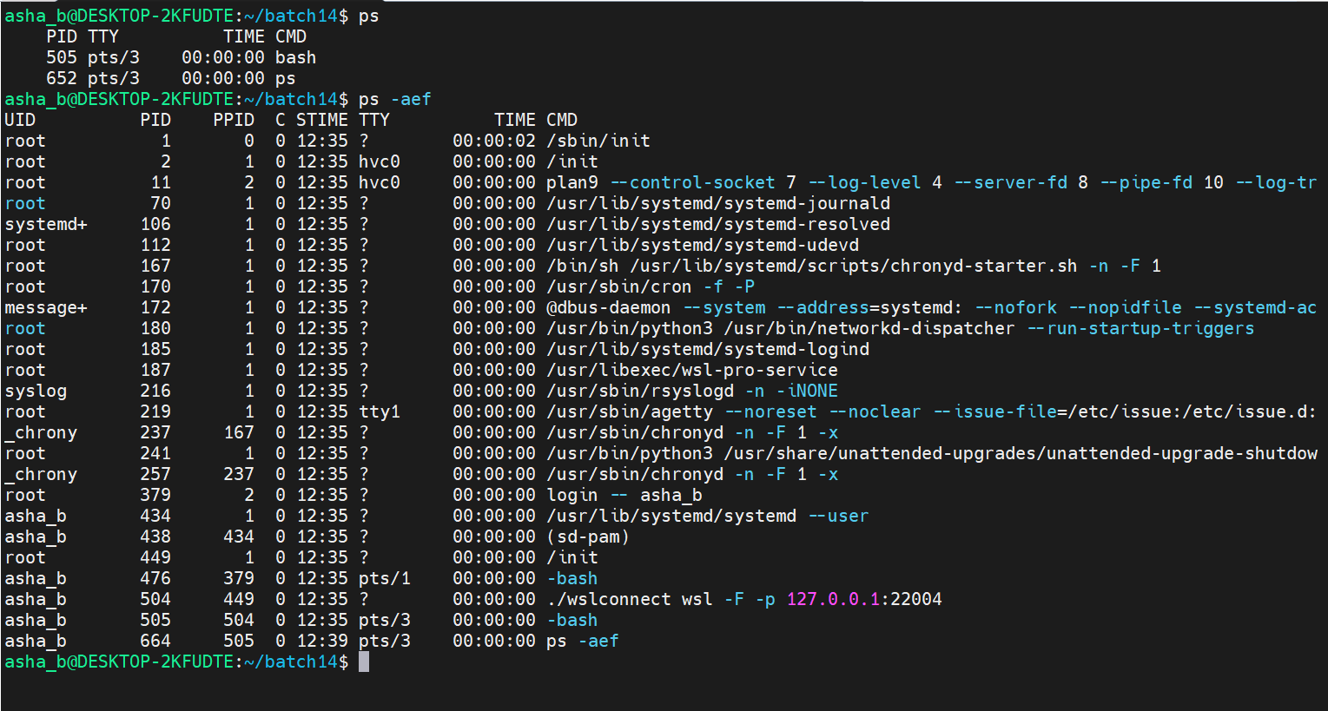

- Terminate a running process using kill and kill -9 command

- ps -aef | grep bash [ To find the Process ID (PID) of a specific running process, here bash, from the process list ]
- kill <PID> [ To send the default signal to the process, asking it to terminate gracefully and allow it to clean up before exiting ]
- kill -9 <PID> [ To send the signal, forcefully and immediately terminating the process, typically used when a normal kill does not stop it ]
- ps -aef [ To verify the process no longer appears in the process list after being killed ]

- View the directory structure in a tree format

- tree [ To display files, directories and links in a hierarchical tree structure ]
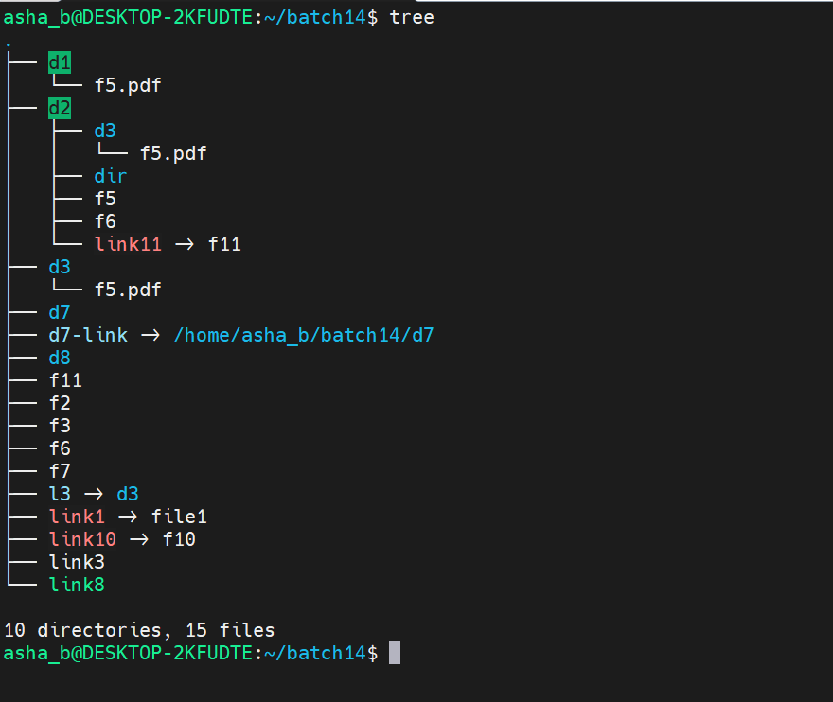

- List all files, directories and links recursively

- find . [ To recursively list every file, directory and link under the current directory, including hidden files ]
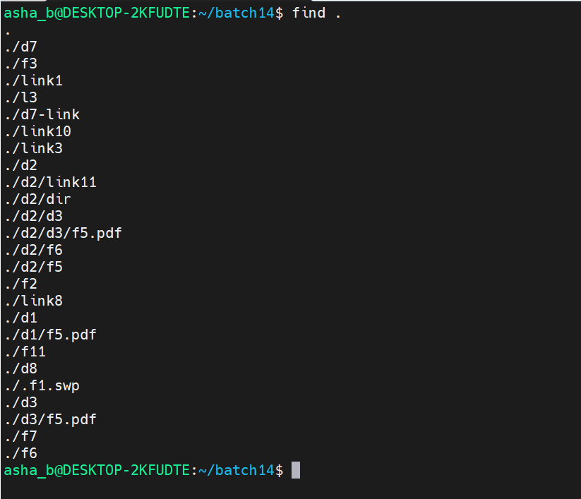

- find . -type f [ To list only regular files ]
- find . -type d [ To list only directories ]
- find . -type l [ To list only symbolic links ]

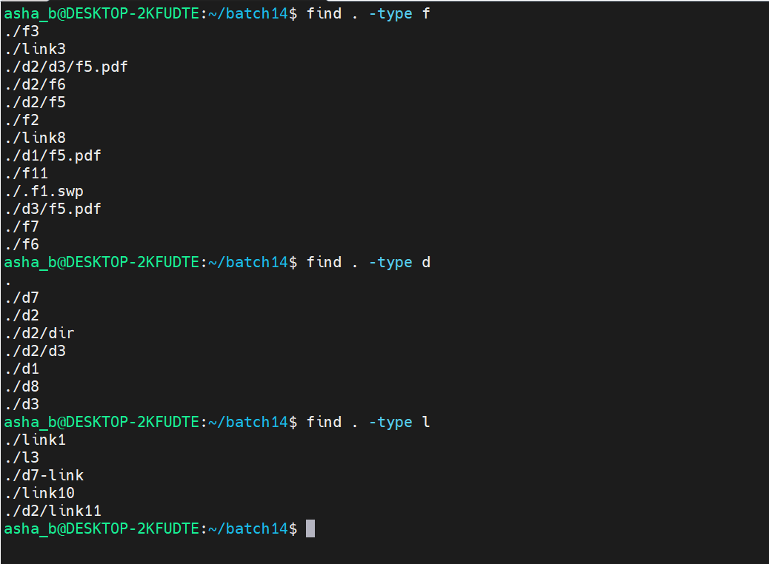
- Find empty files and directories

- find . -empty -type f [ To list only empty files ]
- find . -empty -type d [ To list only empty directories ]

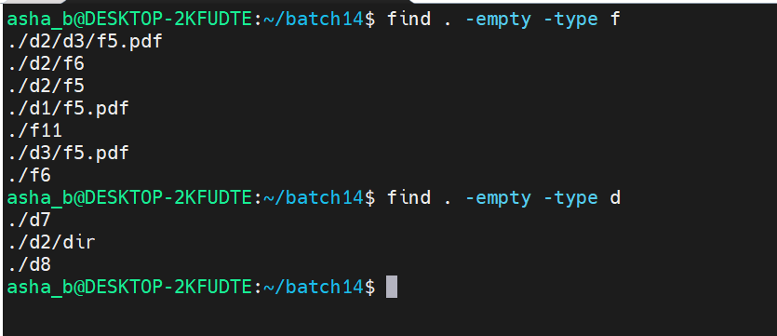

- Search using find with an absolute path

- find /home/asha_b/batch14 [ To recursively list all files, directories and links using an absolute path instead of a relative one ]

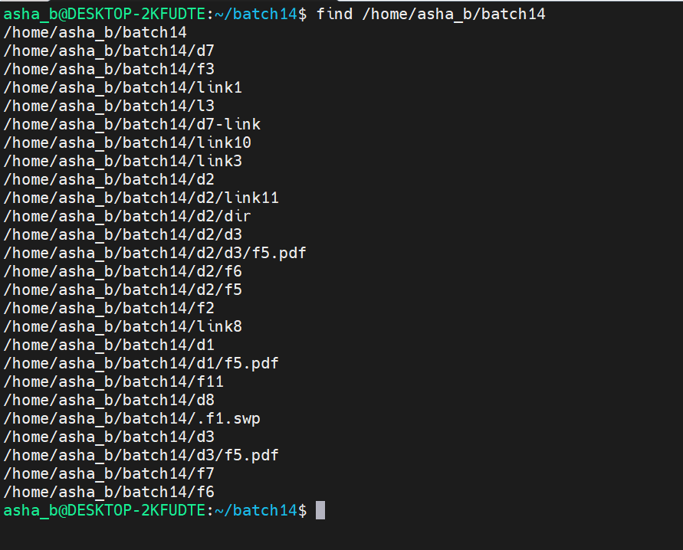
- find /home/asha_b/batch14/d2 [ To list everything inside directory d2 using its absolute path ]
- find /home/asha_b/batch14/d2 -type f [ To list only regular files inside d2 ]
- find /home/asha_b/batch14/d2 -type d [ To list only directories inside d2 ]
- find /home/asha_b/batch14/d2 -type l [ To list only symbolic links inside d2 ]
- find /home/asha_b/batch14/d2 -empty -type f [ To list only empty files inside d2 ]
- find /home/asha_b/batch14/d2 -empty -type d [ To list only empty directories inside d2 ]

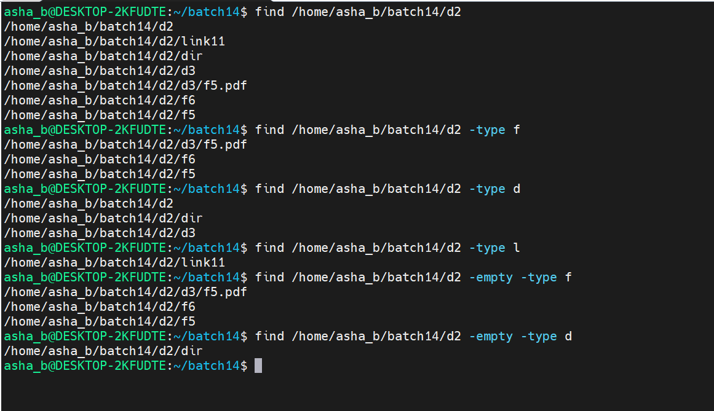

- Search files and directories by permission

- ls -lrt [ To view the permissions of files and directories before searching by permission ]
- find . -perm 777 [ To list files, directories and links that have exactly 777 (full read, write, execute) permissions ]

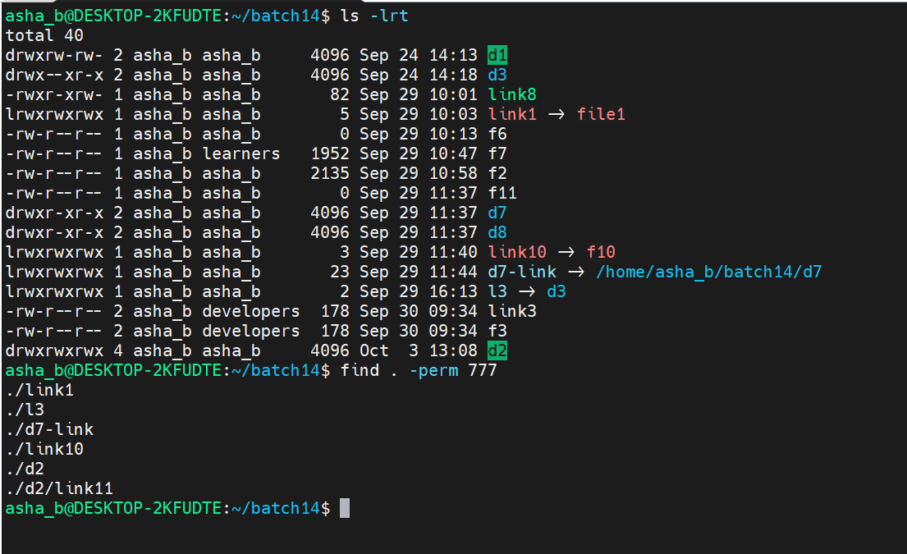

- find . -perm 777 -type d [ To list only directories with 777 permissions ]
- find . -perm 777 -type l [ To list only symbolic links with 777 permissions ]
- find . -perm 644 -type f [ To list only regular files with 644 permissions ]
- find /home/asha_b/batch14/d2 -perm 644 [ To list items with 644 permissions inside d2, using an absolute path ]
- find /home/asha_b/batch14/d2 -perm 777 -type l [ To list symbolic links with 777 permissions inside d2 ]
- find /home/asha_b/batch14 -perm 715 -type d [ To list directories with 715 permissions ]
- find /home/asha_b/batch14 -perm 644 -type f [ To list regular files with 644 permissions ]
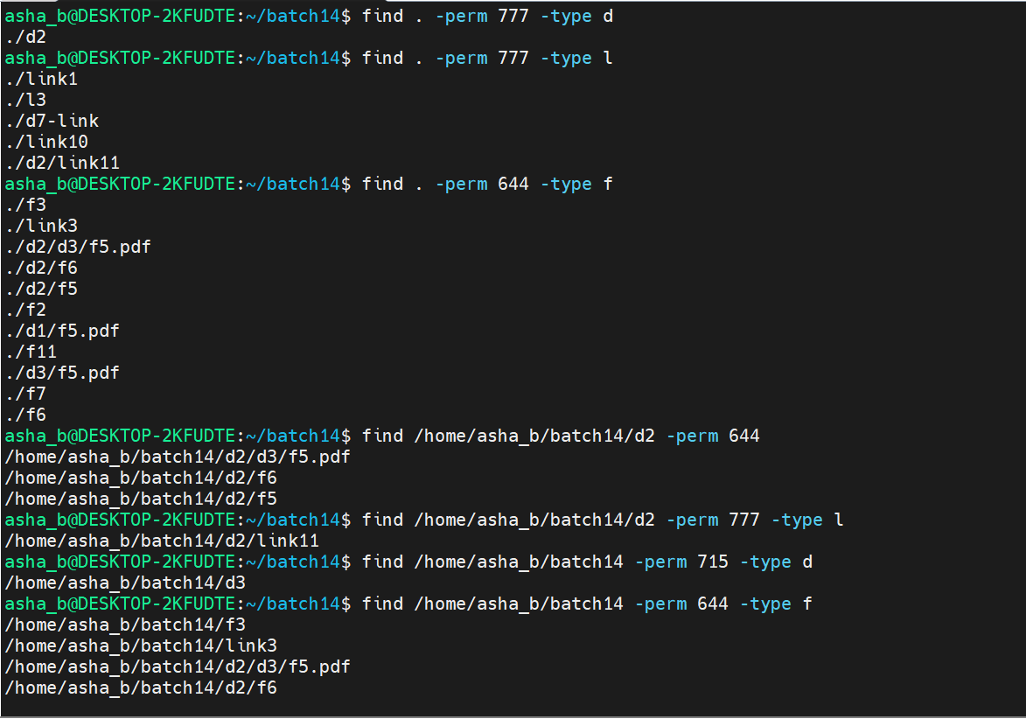

- find . -cmin +15 [ To list all files, directories and links whose status was changed more than 15 minutes ago ]

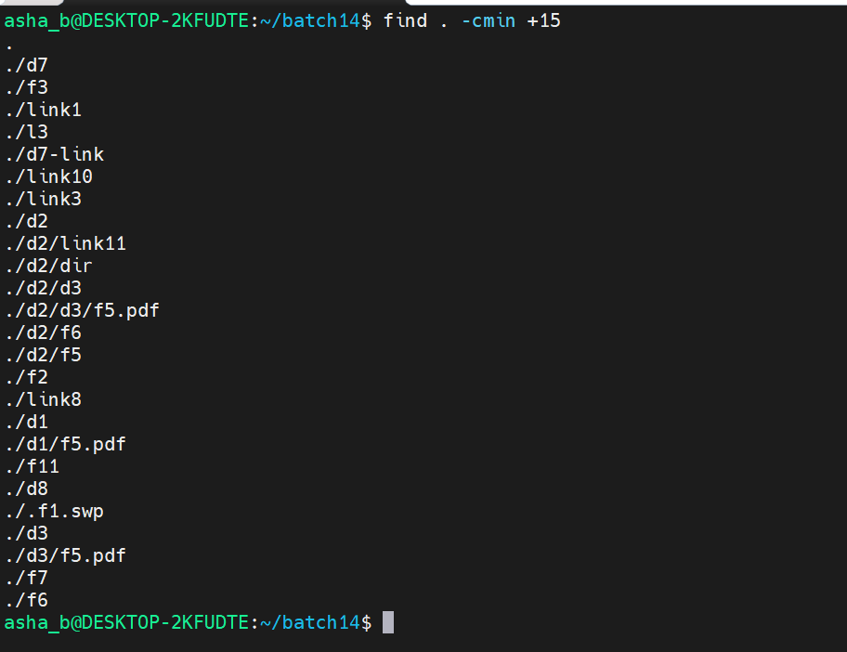
- find . -cmin +15 -type f [ To list only regular files changed more than 15 minutes ago ]
- find . -cmin +15 -type d [ To list only directories changed more than 15 minutes ago ]
- find . -cmin +15 -type l [ To list only symbolic links changed more than 15 minutes ago ]
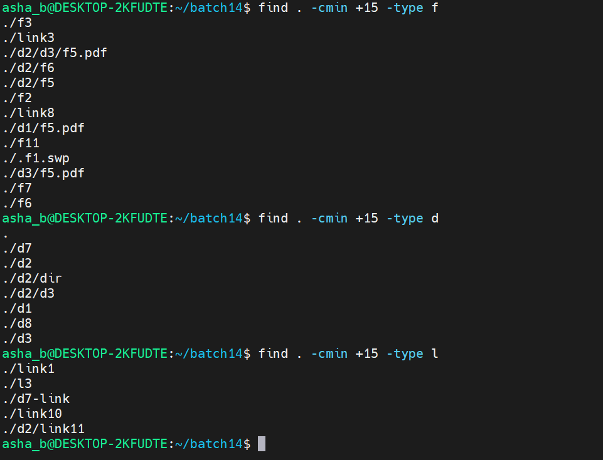

- find . -cmin -15 [ To list items whose status was changed less than 15 minutes ago ]
- find . -cmin -15 -type f [ To list only regular files changed less than 15 minutes ago ]
- find . -cmin -15 -type d [ To list only directories changed less than 15 minutes ago ]
- find . -cmin -15 -type l [ To list only symbolic links changed less than 15 minutes ago (none found) ]
- find . -cmin 15 [ To list items whose status was changed exactly 15 minutes ago (none found) ]
